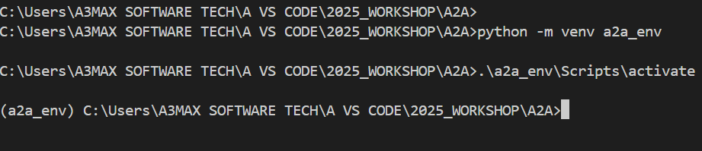
Next step is go to repo https://github.com/google/A2A
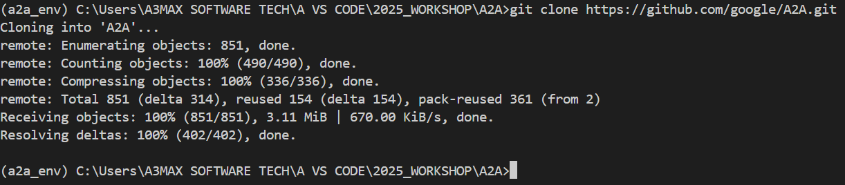
Next step is follow up the documentation for uv install
Going further use uv instead of pip https://docs.astral.sh/uv/guides/install-python/
Next step is to install uv
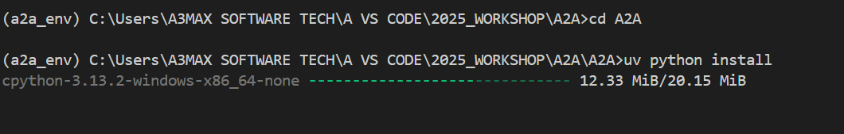
Next step is to install agents crewi dir
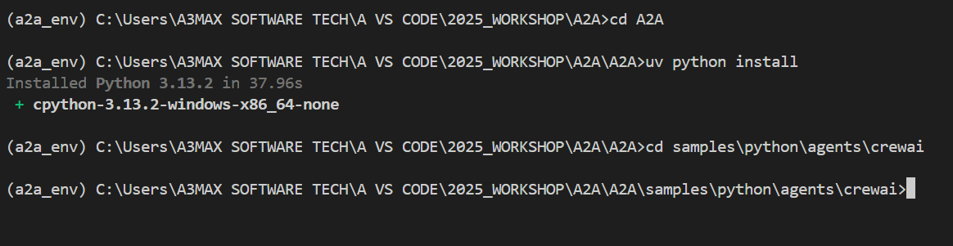
Inside crew ai create a new environment (pip install python-dotenv) finally we create file called .env for (crewai, google_adk & langgraph)
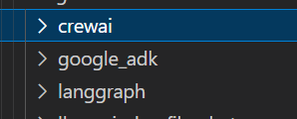
Next step is need to run under crew ai uv run . finally localhost has created
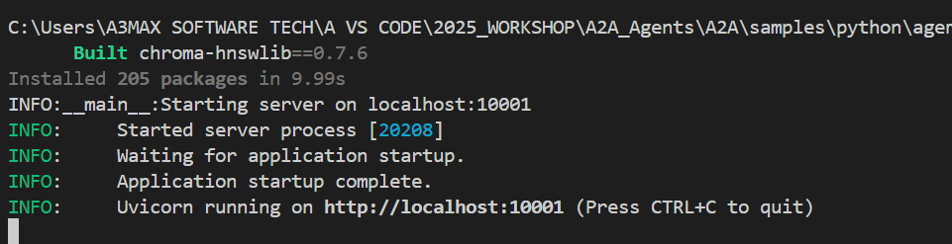
Create another terminal vs code change the prompt to google-adk uv run .
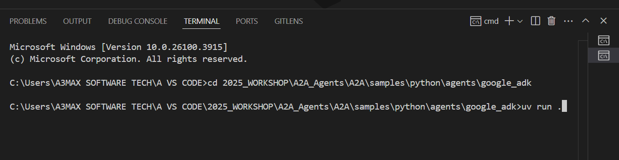
Finally another terminal to langgraph change the prompt to langgraph uv run .
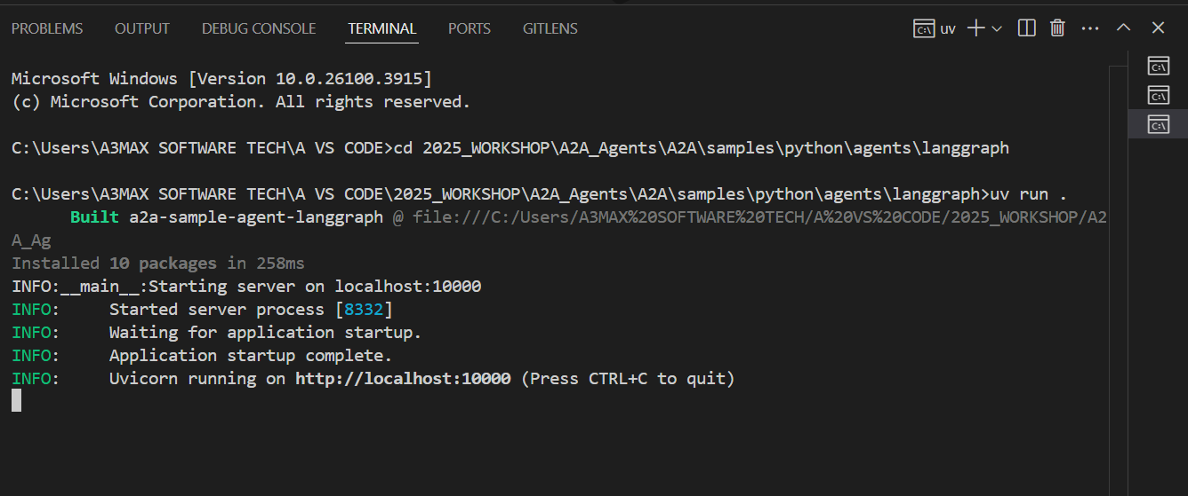
Lets create another terminal for ui go to the demo location cd ui dir uv run main.py
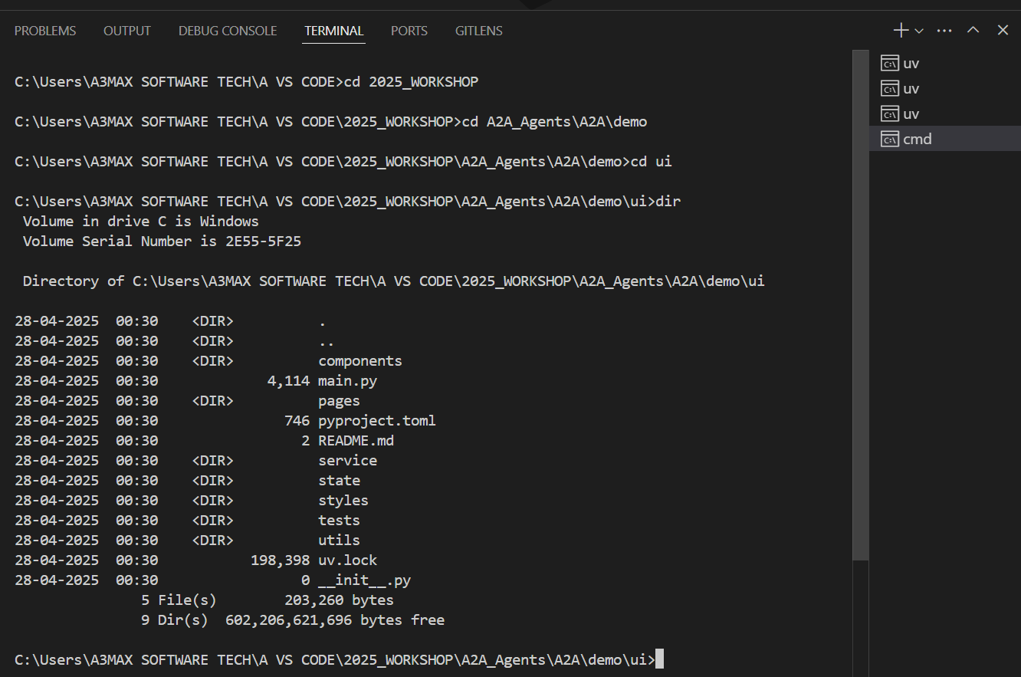

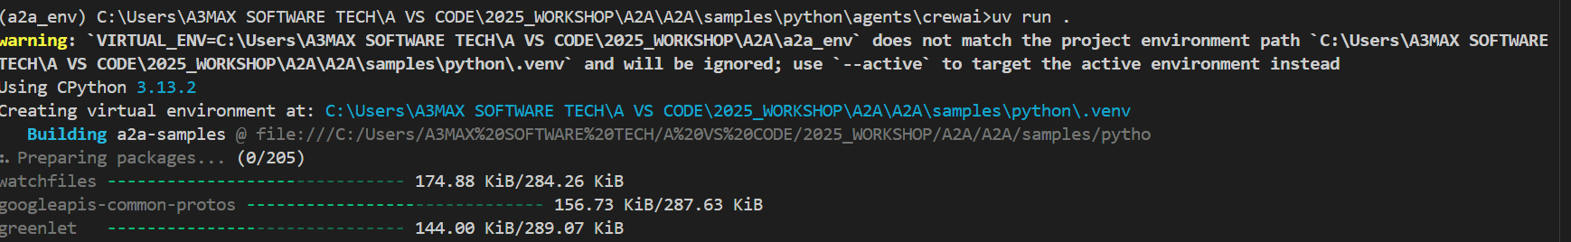
You might get below error so to fix this error you might need to install pip install chroma-hnswlib still you got same error then need to download files from website (https://visualstudio.microsoft.com/visual-cpp-build-tools/)

Also need to select windows 11
You need to install 3 library (pip install crewai || pip install chroma-hnswlib || pip install chromadb==0.4.15)

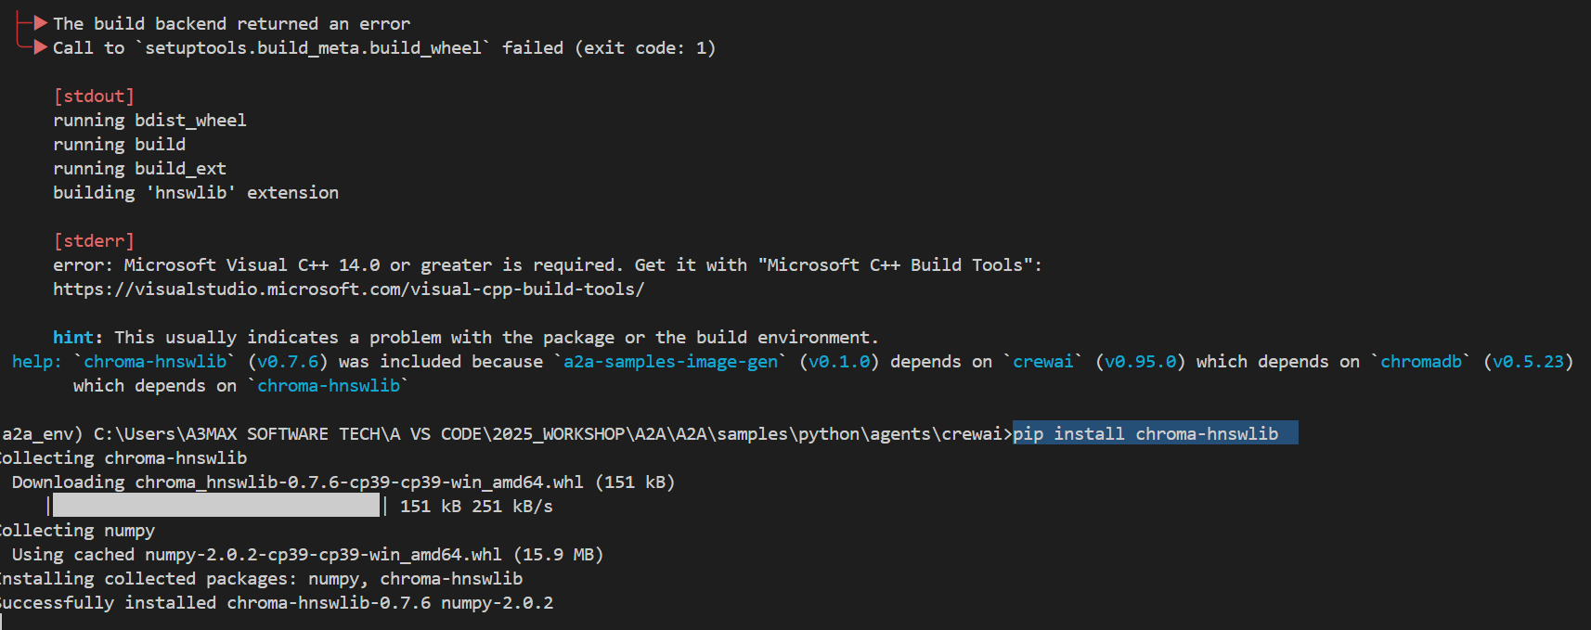
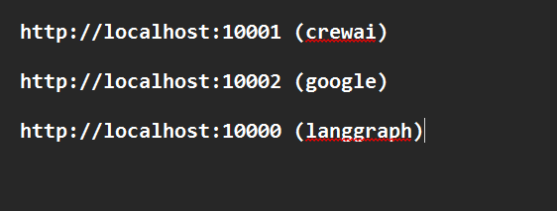
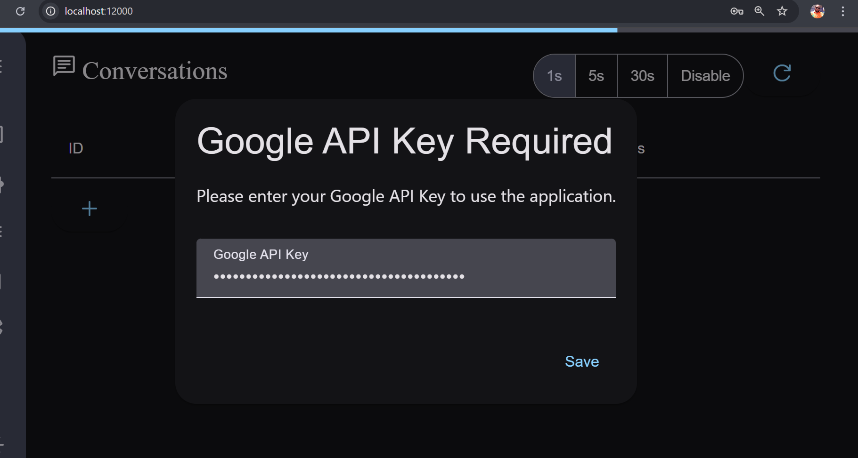
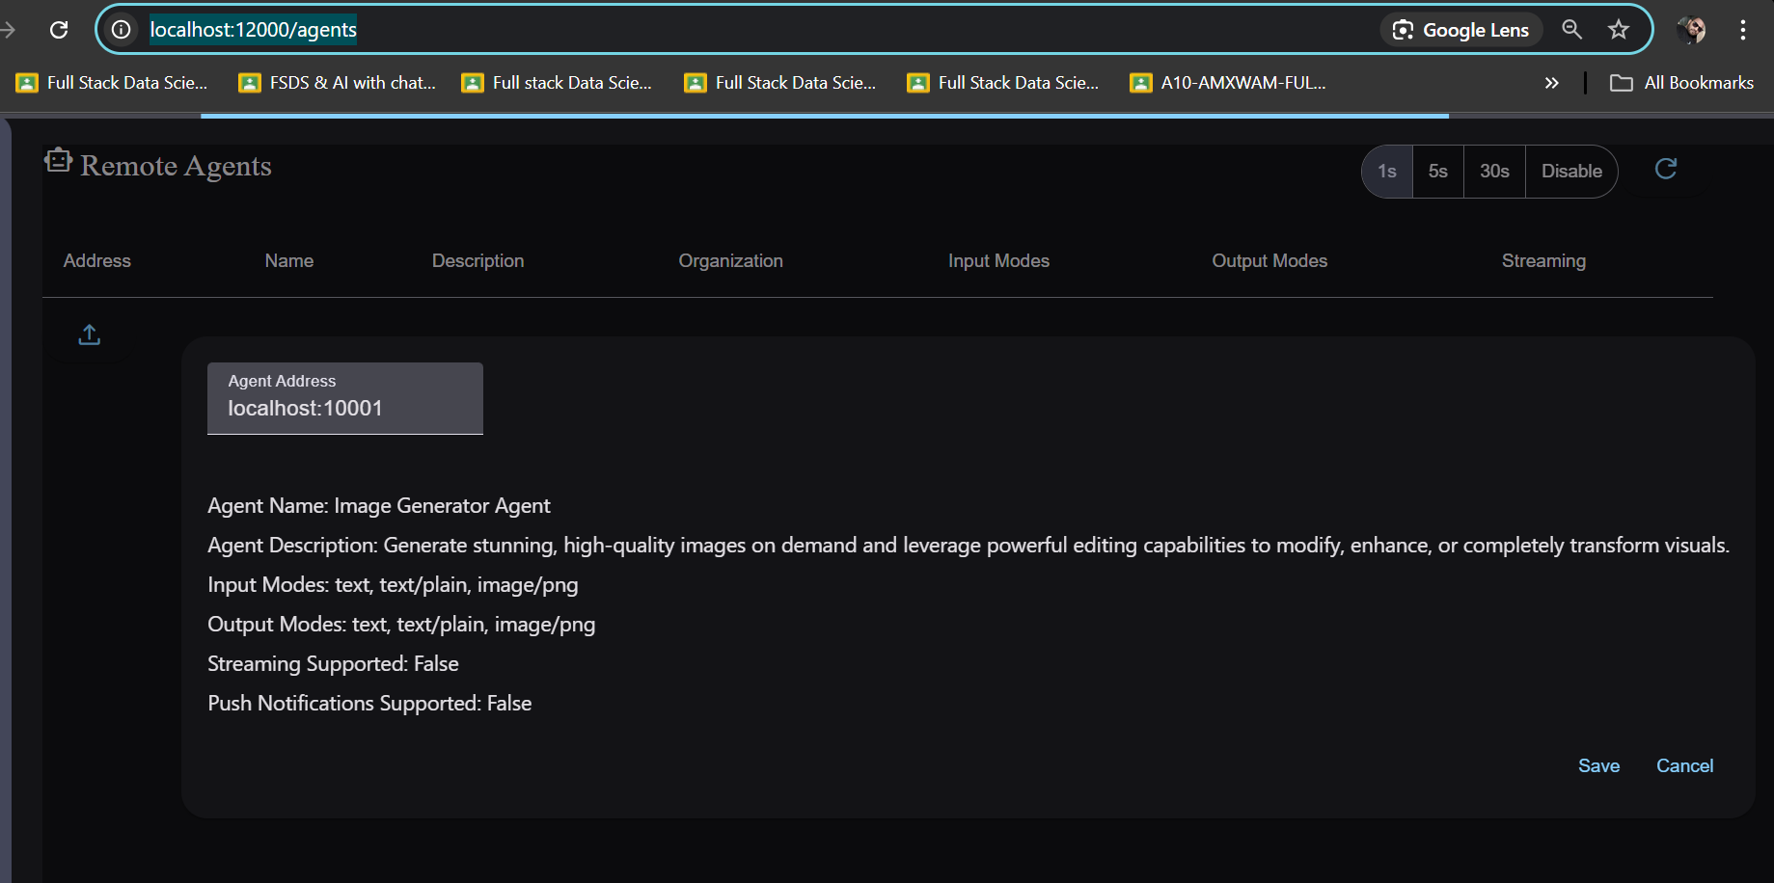
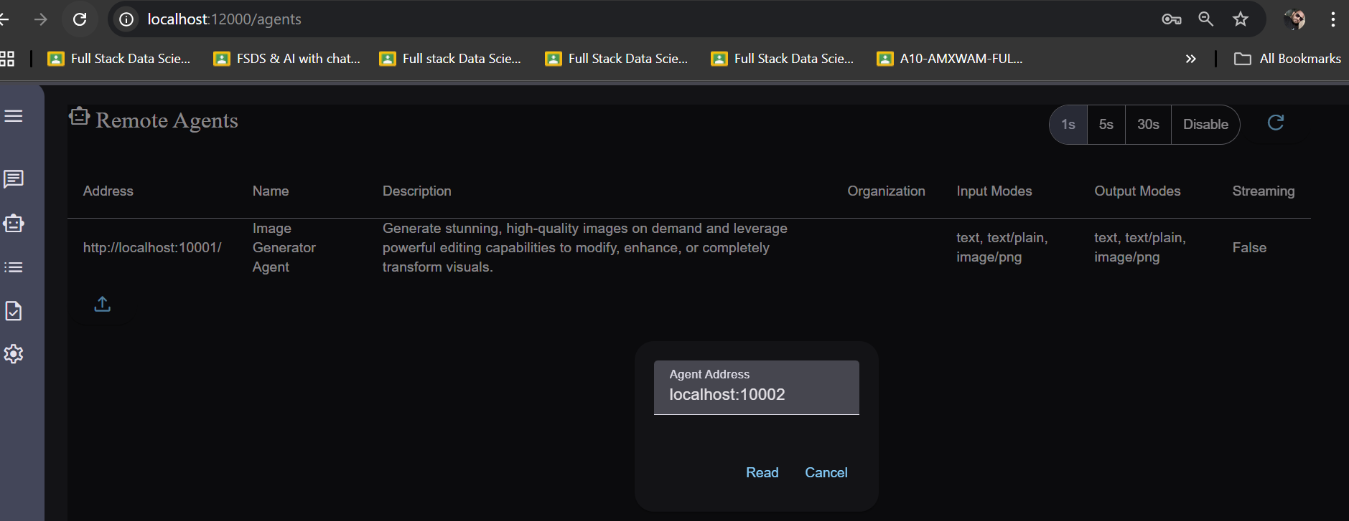
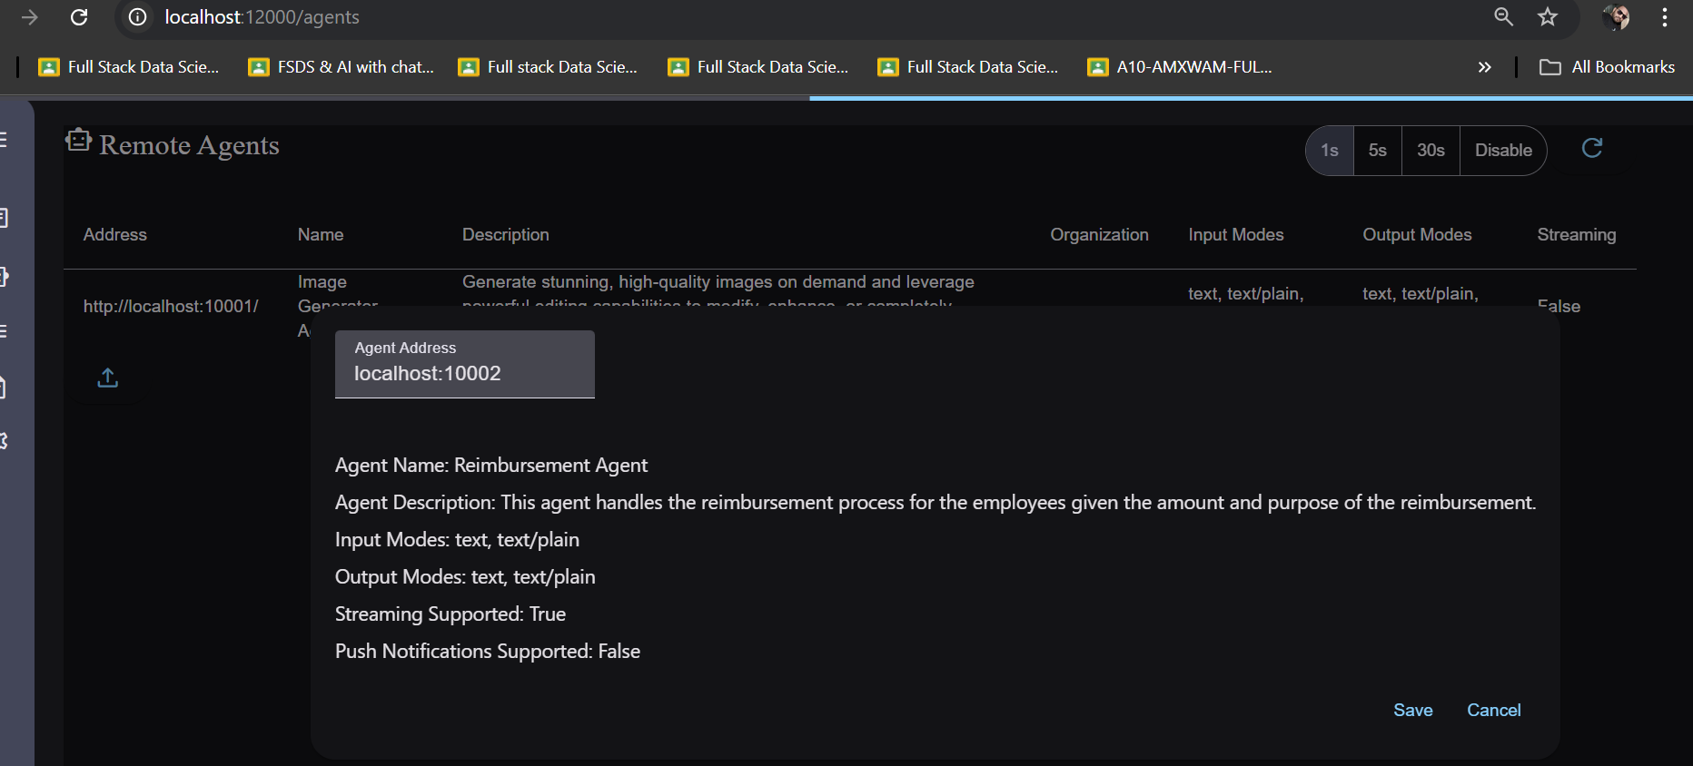
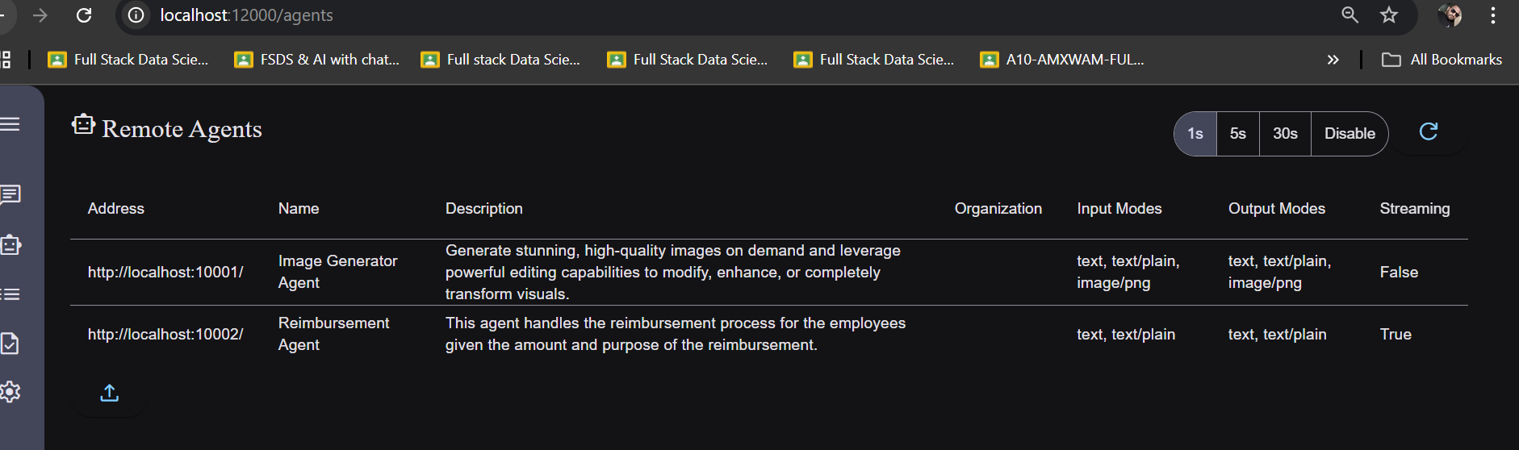
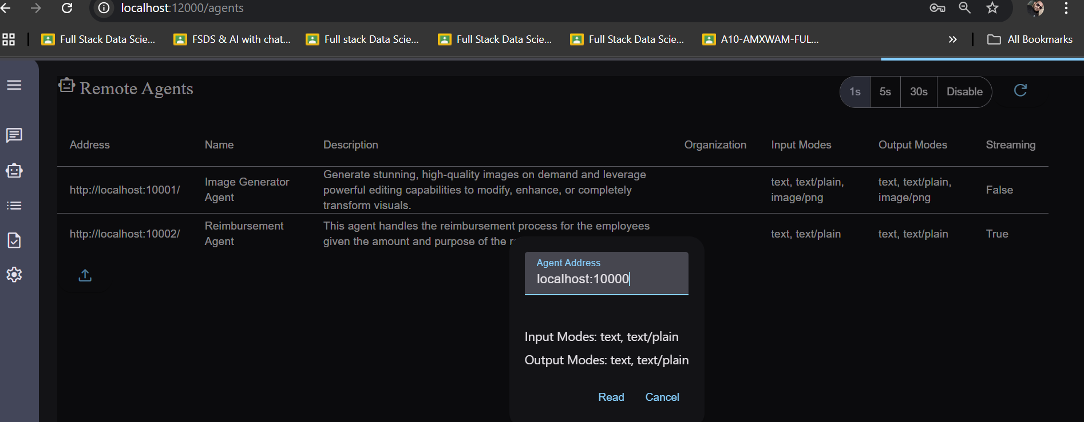
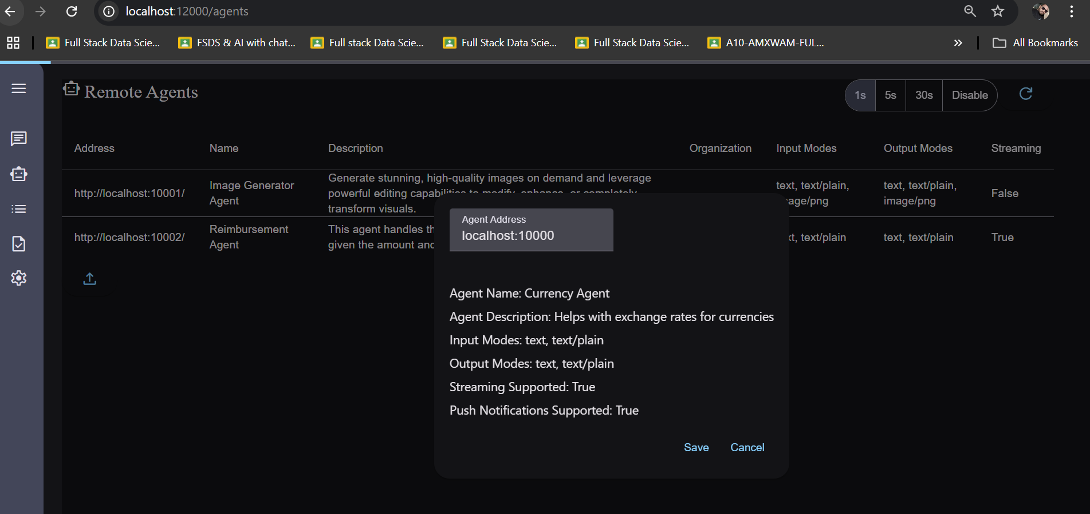
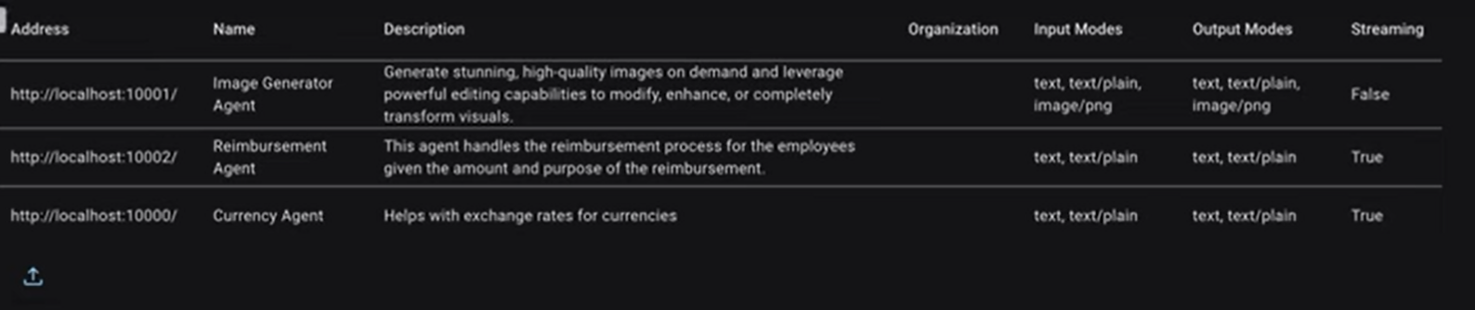

What are the agents available?
